**PikSetu Home Page**

Home page is about pik-setu which is the bridge between the farmers and the traders .In this pik-setu website there are 3 people are going to attached with website:

1. farmers
2. traders
3. pik setu center members

**Home page consists :**

Horizontal Navigation bar at top:

* About pik-setu
* Farmers corner:

1. Farmer registration

2.Farmers login

* pik registration
* Traderscorner :

1.Trader registration

2.Traders login

* Services
* Awards
* Recruitments
* piksearch button/search bar
* account signup

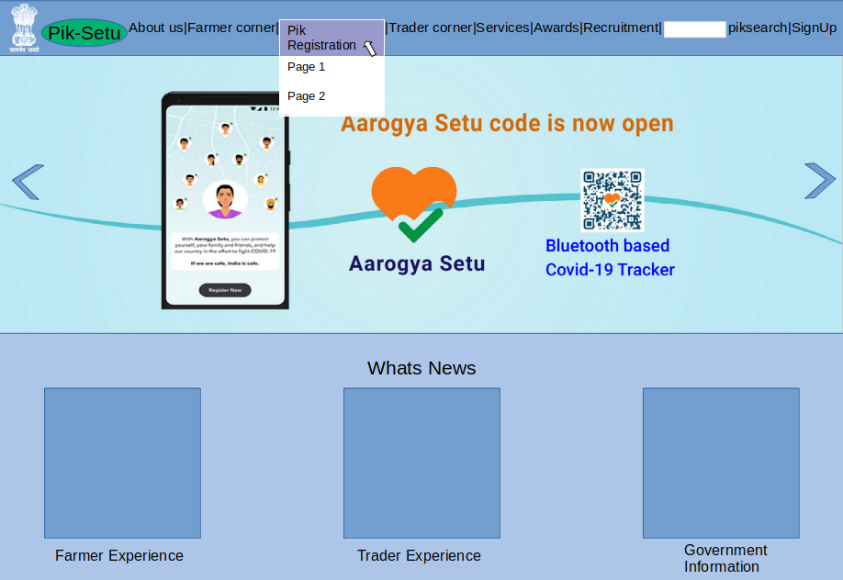**Different panels:**

panel 1:

Consists moving images of government advertisements ,farmers images , progress of pik-setu .

Panel 2:

* contains latest news about the pik setu,
* government steps about the farmers , experience about the benefits gets from pik-setu website ,
* latest trends ,etc.

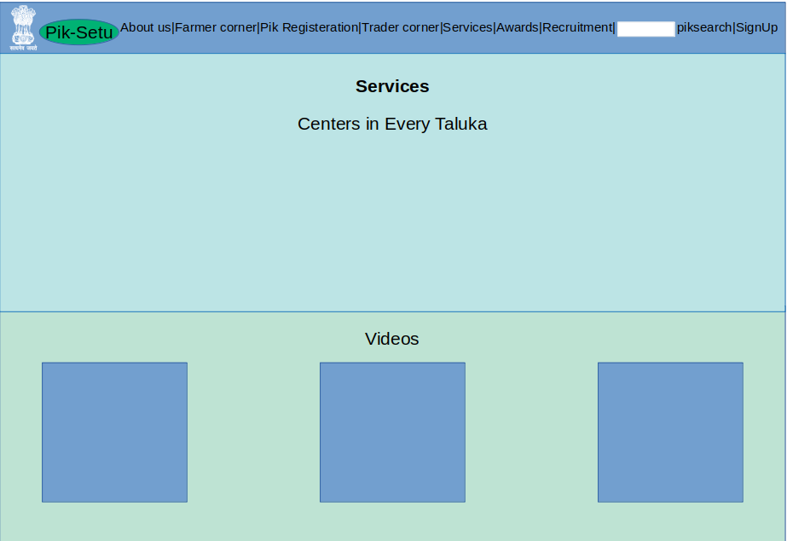

panel 3:

* services (about centers of pik-setu in every taluka.)

panel 4:

* video (getting awards ,news ,sample farms,crops,sucess etc )

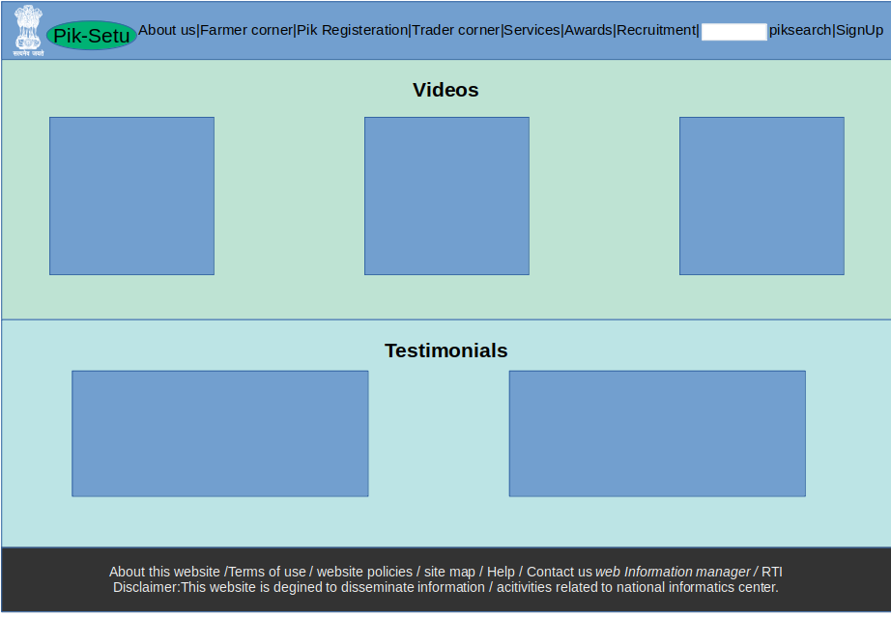

panel 5:

* testimonials ( thoughts of the politician about the pik-setu website)
* It displays there images with there thougts and wishes

panel 6:

* website creation details

For sample layout of web page : <https://www.nic.in/>